1.

U = {0, 1}. How many subsets have U?
A.
1
B.
2
C.
3
D.
4
E.
5

2.

The following addition is done in base ten. What number represents abc?
 | 2 | 2 | 2
 | 3 | 4 | 3
 | a | b | c
1 | 0 | 0 | 0
A.
324
B.
242
C.
423
D.
435
E.
234

3.

Use the mapping below to answer the question below.
2³ → 8
2² → 4
2¹ → 2
2⁰ → a
2⁻¹ → b
The value of a is
A.
0
B.
1
2
C.
1
D.
16
E.
32

4.

Use the mapping below to answer the question below.
2³ → 8
2² → 4
2¹ → 2
2⁰ → a
2⁻¹ → b
What is the value of b?
A.
–2
B.
1
4
C.
1
2
D.
1
E.
2

5.

Write two hundred thousand and fifty seven in figures
A.
20,057
B.
200,057
C.
2,000,057
D.
20,000,057
E.
200,570

6.

What time is the clock below showing?
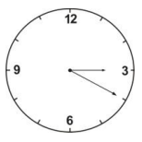
A.
4:30
B.
4:15
C.
3:40
D.
3:20
E.
3:04

7.

Kojo, Ebo and Ama share ₵14,000.00 among themselves. Kojo had twice as much as Ebo and Ebo also had twice as much as Ama. How much did Ebo get?
A.
₵8,000.00
B.
₵6,000.00
C.
₵4,000.00
D.
₵3,000.00
E.
₵2,000.00

8.

At what rate of simple interest will ₵5,000.00 amount to ₵7,500 if saved for 5 years?
A.
5%
B.
6
2
3
%
C.
7
1
2
%
D.
10%
E.
12
1
2
%

9.

Simplify
1
3
-
1
2
+
2
5
A.
17
30
B.
13
30
C.
7
30
D.
-
7
30
E.
-
17
30

10.

If 2^{x} = 8, what is the value of x?
A.
0
B.
1
C.
2
D.
3
E.
4

11.

Use the following information to answer the question below.
The relation between the Celsius (C) and Fahrenheit (F) scale of temperature is given by:
C =
5
9
(F - 32).
If C is 40, F will be
A.
104.0
B.
78.4
C.
72.0
D.
65.6
E.
40.0

12.

Use the following information to answer the question below.
The relation between the Celsius (C) and Fahrenheit (F) scale of temperature is given by:
C =
5
9
(F - 32).
If C is –40, find the value of F
A.
–104.0
B.
–78.4
C.
–72.0
D.
–65.6
E.
–40.0

13.

Use the information below to answer the question below.
The ages in years of 9 children at a birthday party are 2, 3, 3, 3, 4, 5, 5, 5, 6.
What is the mean age?
A.
3.0
B.
3.5
C.
4.0
D.
4.5
E.
5.0

14.

Use the information below to answer the question below.
The ages in years of 9 children at a birthday party are 2, 3, 3, 3, 4, 5, 5, 5, 6.
What is the median age?
A.
2.0
B.
3.0
C.
3.5
D.
4.0
E.
5.0

15.

Use the information below to answer the question below.
The ages in years of 9 children at a birthday party are 2, 3, 3, 3, 4, 5, 5, 5, 6.
If a child is picked at random, what is the probability that he is 5 years old?
A.
2
9
B.
1
3
C.
4
9
D.
5
9
E.
2
3

16.

P(2, 5) and Q(-2, 3) are points in the Cartesian plane, find the vector PQ
→
.
A.
(
4
2
)
B.
(
-4
-2
)
C.
(
4
-2
)
D.
(
-4
2
)
E.
(
0
-2
)

17.

Find k in the vector equation
(
3
4
)
+ k
(
3
4
)
= -
(
3
4
)
.
A.
-3
B.
-2
C.
-1
D.
-
3
4
E.
2

18.

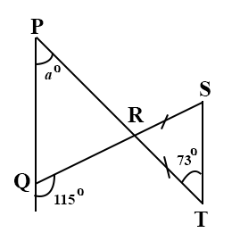
In the above diagram, |RS| = |RT|. Find a
A.
146°
B.
81°
C.
73°
D.
65°
E.
34°

19.

If a² – b² = (a + b)(a – b), evaluate 9.32² – 0.68²
A.
87.32
B.
86.4
C.
74.65
D.
10.0
E.
8.64

20.

Simplify
6
2
2
2
x3
A.
1
B.
2
C.
3
D.
6
E.
9

21.

The sum of the ages of Kwaku and Kojo is 30 years. Kwaku is 4 years older than Kojo. How old is Kojo?
A.
19
B.
17
C.
13
D.
11
E.
9

22.

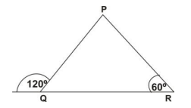
What type of triangle is ∆PQR?
A.
Equilateral
B.
Isosceles
C.
Scalene
D.
Right-angled
E.
Obtuse-angled

23.

Use the equation y = (x + 2)(x - 2) to answer the question below
If x = -1, find y.
A.
–4
B.
–3
C.
3
D.
4
E.
9

24.

Use the equation y = (x + 2)(x - 2) to answer the question below
Find the set of values of x for which y is zero.
A.
{0}
B.
{0,2}
C.
{0,-2}
D.
{-2,2}
E.
{2}

25.

Use the information below to answer the question below
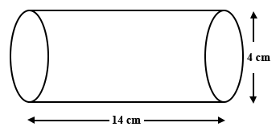
In the diagram above, the cylinder has diameter 4 cm and length 14 cm.
[Take π =
22
7
]
Find the circumference of the base.
A.
44
7
cm
B.
88
7
cm
C.
176
7
cm
D.
44 cm
E.
176 cm

26.

Use the information below to answer the question below
In the diagram above, the cylinder has diameter 4 cm and length 14 cm.
[Take π =
22
7
]
The area of the base is
A.
176 cm²
B.
44 cm²
C.
176
7
cm²
D.
88
7
cm²
E.
44
7
cm²

27.

Use the information below to answer the question below
In the diagram above, the cylinder has diameter 4 cm and length 14 cm.
[Take π =
22
7
]
What is the volume of the cylinder?
A.
176 cm³
B.
44 cm³
C.
176
7
cm³
D.
88
7
cm³
E.
44
7
cm³

28.

A woman bought 210 oranges for ₵650.00. She sold all of them at 3 for ₵20.00. How much profit did she make?
A.
₵350.00
B.
₵450.00
C.
₵550.00
D.
₵650.00
E.
₵750.00

29.

The ratio of boys to girls in a school is 9 : 11. If there are 400 pupils in the school, how many boys are there?
A.
80
B.
120
C.
180
D.
220
E.
280

30.

Express the product of 162.5 x 0.5 in standard form.
A.
81.25 x 10⁻¹
B.
81.25 x 10
C.
8.125 x 10⁻¹
D.
8.125 x 10
E.
0.8125 x 10⁻²

31.

What is 16% of ₵500,000.00?
A.
₵80
B.
₵8,000
C.
₵80,000
D.
₵420,000
E.
₵492,000

32.

Simplify
0.24 x 14.3
5.2
A.
66
B.
6.60
C.
0.70
D.
0.66
E.
0.60

33.

The product of 2x and 3 is 138. Find x
A.
23
B.
33
C.
68
D.
69
E.
138

34.

Use the graph below to answer the question below.
The travel graph describes the journey of a cyclist from Town X to Town Y.
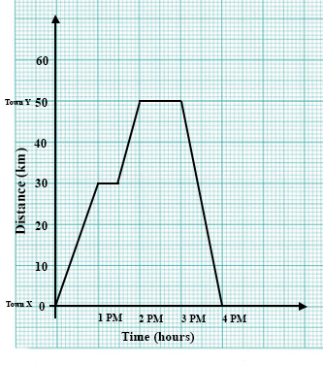
What was the average speed for the return journey from town Y to town X
A.
100 kmh⁻¹
B.
50 kmh⁻¹
C.
33.33 kmh⁻¹
D.
25 kmh⁻¹
E.
20 kmh⁻¹

35.

Use the graph below to answer the question below.
The travel graph describes the journey of a cyclist from Town X to Town Y.
State the period within which he travelled to town Y after his first rest?
A.
1:00 – 2:00 pm
B.
1:00 – 4:00 pm
C.
1:15 – 1:30 pm
D.
1:30 – 2:00 pm
E.
2:00 – 4:00 pm

36.

Use the graph below to answer the question below.
The travel graph describes the journey of a cyclist from Town X to Town Y.
How many minutes did the cyclist spend at town Y?
A.
15 minutes
B.
20 minutes
C.
30 minutes
D.
45 minutes
E.
60 minutes

37.

200 bottles of equal capacity hold 350 litres of water. How much water does each bottle hold?
A.
1750 litres
B.
175 litres
C.
17.5 litres
D.
1.75 litres
E.
0.17 litres

38.

Find the solution set of 2x + 4 > -6
A.
{x = -5}
B.
{x < 5}
C.
{x > 5}
D.
{x < -5}
E.
{x > -5}

39.

A rectangular field 50 metres wide and x metres long requires 260 metres of fencing. Which of the following statements is true?
A.
x + 100 = 260
B.
2x + 50 = 260
C.
4x + 200 = 260
D.
2x + 100 = 260
E.
4x + 100 = 260

40.

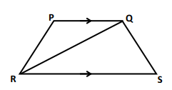
In the diagram above, PQSR is a trapezium. PQ is parallel to RS. ∠PQR = ∠QRS. What type of triangle is triangle RQS?
A.
Isosceles
B.
Scalene
C.
Equilateral
D.
Right–angled
E.
Obtuse-angled

